OOSH Newcastle Centre’s
Parent Handbook
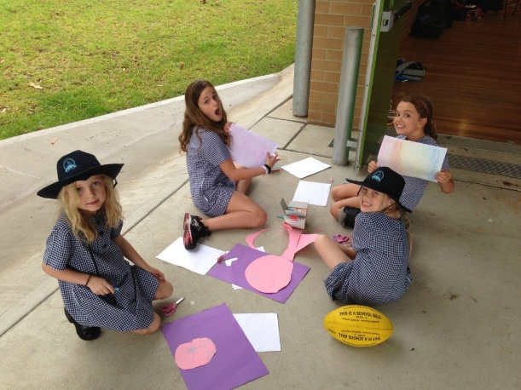
Service Locations Include:
Merewether Heights Public School
Located in Merewether Heights Public School
Off Scenic Drive, Merewether Heights NSW 2291
Phone: 0412 787 605/ 4963 5654
Mount Hutton Public School
Located in Mount Hutton Public School
12 Dunkley Parade, Mount Hutton NSW 2290
Phone: 0431 411 758/ 4948 0276

Table of contents

Introduction………………………………………………………………….….Page 3
About Our OOSH Services/Methods of Payment….……..…..Page 4
Hours of operation…………………………………………………………..Page 5
Fees and charges……………………………………………………………..Page 6
Centre Philosophy……………………………………………………………Page 7
Priority of access-
Preparing for your first day-
Orientation-
What to expect…………………………..……………………………………Page 8-9
Arrivals and departures……………………………………………………Page 10
Absences/Learning environment……………………………..……..Page 11
Framework……………………………………………..……………………….Page 12
Care of Children……………………………………………………………….Page 13
Child Protection…………………………………………………………….…Page 14
Policy and Procedures………………………………………………………Page 15
Health and safety…………………………………………………………….Pages 15-18
Complaints or Praise Information…………………………………….Page 19
Parent User Agreement Form…………………………………………..Page 20

Introduction
Hello and Welcome!
This handbook provides information about all OOSH Services operated by Larissa Street and her team. It is designed to help you prepare for your child’s introduction to our before and after school care. We wish to extend a warm welcome and acknowledge you and your family.

Merewether Heights and Mount Hutton OOSH’s all have a wonderful team of dedicated and highly qualified staff to provide a high quality of care for your children. At our OOSH services we ensure we have the required staffing ratios and qualifications. We employ qualified educators with a range of qualifications who have a passion for working with children.
We work within the new regulations and ensure we follow all the laws pertaining to childcare.

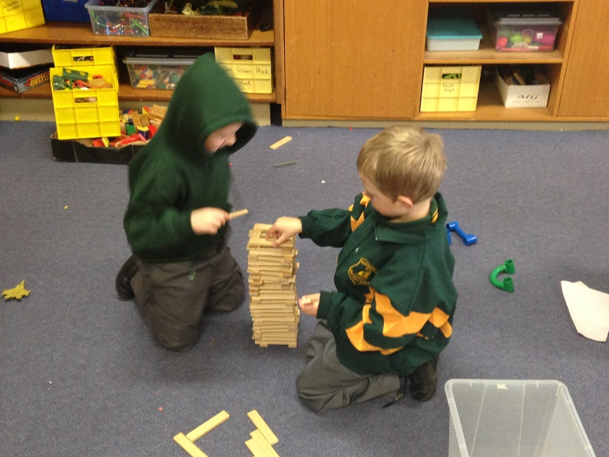

About Our OOSH Services.

The goal of Merewether Heights and Mt Hutton OOSH is to provide the highest quality of care for school age children. We strive to provide a happy, safe and relaxed environment for your children, with our friendly and caring staff our centre will be nurturing, home-like feel for children aged 4 to 12 years. We understand that for some families the pressures of work can fall after school hours which is why we provide the care before and after school.
We understand that each child has their own unique talents, learning style and personalities, our qualified staff are committed to working within each child’s comfort zone to ensure optimal social, emotional, physical and physiological needs are met. The activities that we provide are stimulating, engaging and fun while maintaining the need for children to learn.
We will also provide an extensive variety of delicious afternoon teas and on occasion have “hot cooked” breakfast mornings.

Method of Payments:
We accept 3 forms of payment. Cash, EFTPOS card machine, and Internet transfer of funds.
Our Bank Account details are permanently on your invoice.
Our account details are:

Merewether Heights OOSH
BSB: 650 000
Account Number: 970 426 002
Account Name: Merewether Heights OOSH

Mount Hutton OOSH
BSB: 650 000
Account Number: 502 692 318
Account Name: Mount Hutton OOSH

We are all fees up front services. We will invoice every family every week. We expect by Thursday night of every week each family will have their fees paid in full and up to date.
Any family that falls behind more than two weeks, we stop providing care for.
We have a no fees, no childcare policy. More detail of this is in the fees policy.

Hours of Operation:
Term Hours:
Mount Hutton OOSH Services
Prior booking can be made for 6.30am start.
Before School Care – 7am-9am
After School Care – 2.30-6pm

Merewether Heights and Mount Hutton operate Vacation Care
Vacation Care Hours: 7am – 6pm. 10 hour limit per day.

Rationale:
We as professionals aim to meet the needs of parents in our community who either work, study or have other commitments, by operating our service for days and hours that allow them to reasonably get from work or place of study.

Before school care:
7am to 9am Daily

Short afternoon care up to STRICTLY 4pm.

Standard after school care: 3pm to 6pm

Our centre is open all weeks of the term year.
The centre will be closed on designated public holidays; all parents will be notified in advance of these days. We do not charge for Public Holidays.

Operating hours will be reviewed yearly to ensure that they meet the needs of all parents.

Fees and charges 2016
Before School Care
Permanent Booking
$14.00 per child
Casual Booking
$15.00 per child

After School Care
Short Afternoon Care- 3.00 to 4.00pm
$8.00 per Child
Casual Short Afternoon
$8.50 per child.
Short Afternoon Care has a STRICT cut off of 4pm.
Permanent Booking
$16.00 per child
Casual Booking
$17.00 per child
These are the charges before the Child Care Benefit Discount

Yearly Enrolment Fee – Charged to all children each year - $25 to cover life insurance of children. Charged end of February each year or once enrolled.
We are happy for families to pay this off over several weeks.

Centre Philosophy

Our service strives to provide reliable, cost effective Out of School Hours Care, accessible to all families within the School community by maintaining the highest quality standards of service in a happy and stimulating environment.
We are committed to maintaining the highest quality standards of service in a positive and stimulating environment with fun programming and that allows children to choose how their time will be spent at oosh. Child directed play as well as structured activities provide opportunities for children to explore, experiment, as well as interacting with others. We recognise the significance of children being engaged in meaningful opportunities.
We recognise the significance of family culture and community on children’s sense of belonging. Diversity is reflected and supported so that the children feel a strong sense of identity and understanding and respect for others. We encourage children and parents to be actively involved in the planning and implementation and evaluation of the program.
We understand the developmental differences of children aged 5-12 years as well as their similarities. Children are shaped by many experiences and are very capable at supporting one another and building on each other’s skills and knowledge bases. Their willingness to become active members of society is supported in our routines and everyday experiences and aims to develop a strong sense of identity and well-being.
Our Goals
- Provide a friendly, caring and safe environment that provides high quality care for children
- Provide a welcoming environment for staff, parents and children and develop collaborative relationships
- Encourage health and well-being by providing nutritious snacks, modelling healthy eating habits and providing physically active play experiences.
- Acknowledge that children are capable, resourceful and active contributors in their learning.
- Recognising the uniqueness of each child and encouraging their sense of identity and well-being.
- Promoting play and leisure as intrinsically interwoven in physical, social, emotional, personal, creative, cognitive and linguistic aspects of learning.
- Developing positive relationships with the local schools and services in the community.

Priority of access
We aim to provide a place for school aged children during their time out of school hours. We will not discriminate against any families needing care; however priority of access will be determined by the guidelines and placement on waiting list. We care for many children with diverse special needs and do have a limit of the number we take a day. This is to ensure that all children are cared for in a fair and equitable way. Once our limit is reached for special needs children, we do refuse care for further numbers, if our staffing has reached its limit.

Preparing for your First Day
Orientation
All parents are encouraged to spend some time at the centre with their child before enrolment to support transition to before and after school care. This affords your child some time to play, become comfortable with the routine and environment and build trusting relationships with the teaching team with your support. It also offers you the opportunity to meet the educators in the team, understand the program and develop a partnership with us.

What to Expect
Each child’s first day is different and children require different periods of time to settle into what is sometimes the first experience away from family and home. We recognise that this is an important transition and we will do all we can to make it a positive experience.
Generally the first day is filled with lots of new and exciting experiences. They will generally be happy.
Please make sure you tell your child when you are leaving and when you will return. You are most welcome to ring us if you are concerned and we will contact you if needed. In the first days of OOSH or Vacation care, the focus of the program is to provide the children with a caring and secure environment where they will become confident and independent. We introduce basic routines and assist the children to establish a safe and co-operative play environment.

What to Expect
We encourage healthy food at OOSH. There is a NO NUTS and no nut products policy at OOSH.

Our OOSH morning will have a variety of activities out for the children to use in the morning. From 7.15am onwards we will have breakfast club running for those who need breakfast. This finishes at 8am. This is for early starters of the day. Anyone coming after 8am will need to have had their breakfast at home.
We will supply everyday on offer to choose from:
Several cereal choices, the children will give us feedback on what they like to eat.
Toast: Plain or Raisin – various toppings including grilled cheese or vegemite, honey, jam etc.
Chilled Water
Milk: Plain or with milo – hot or cold.

When we do a hot breakfast morning, we will offer pancakes, French toast and eggs cooked anyway in addition to what we already have on offer.

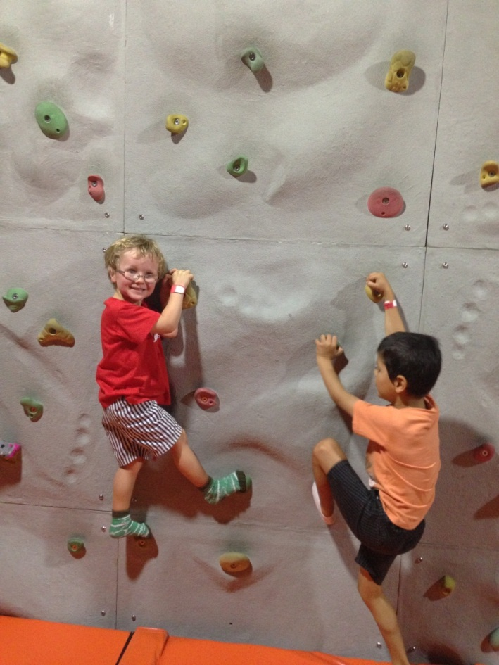
Arrivals and Departures
On arrival each day
- Sign your child in on the attendance register, these sheets are located inside the OOSH room and are an essential part of the service record keeping. Please record times and sign these records accurately as we refer to them for both emergency and funding purposes. Check communication day board located above sign in sheet.
- Hand any medications to educators and complete the appropriate form
- Apply sunscreen and or Mozzie repellent to your child if needed.
- Encourage your child to greet educators and children with you
- Discuss any relevant information about your child’s needs.

On Pick up each day
- Sign out on the attendance register
- Check communication day board.
- Ensure your child has collected their personal belongings.
- Collect art and craft
- Encourage your child to say goodbye to educators/staff

Children can only be collected by their parents or other authorised person/s.
Any person delegated to collect your child will be requested to show proof of identity, e.g. Drivers Licence or other photo identification card before being allowed to collect the child. This applies to only people that are not standard pick up adults that are not known to staff.
Please inform us if:
- Anyone other than the nominated person/s on the enrolment form is picking up your child
- Your contact details or your emergency contact details have changed.
- There is a change in access or custody – staff members are unable to follow instructions in this regard without supporting legal documentation.

Absences
If your child is going to be absent on an enrolled day, please ring and notify us. The staff ratios and programs for the days are based on the attendance rolls.

Please also advise the service if your child has a contagious disease e.g. Chicken Pox.

This way we can put up a notification about an infectious disease for other families to be aware of.

Learning Environments
At Merewether Heights and Mount Hutton OOSH we believe learning environments for children should provide a framework to stimulate growth, development and creativity through play and exploration. The environment is peaceful, attractive and inviting to the child, parents and educators.
It is also flexible and adaptable to the children’s changing and ongoing needs.

The inclusion of special cultural articles or features from educators and families represent the interests and culture of the group and contribute to a sense of belonging. We also provide a communication diary for all the parents to inform us of their child’s interests so we can incorporate it in our program.
Our comfortable indoor and outdoor areas invite our children to interact with one another in various play spaces.
We like to consider our OOSH is like the children are at home having a play date with lots of other children from school.

Framework
At our OOSH under the current government regulations we follow the My Time, Our Place Framework for school age children. This framework assists our service in following the regulations and laws and the principles, practice and outcomes to accommodate the contexts and age range of the children and young people who attend school age care settings.
The framework for school age children exists to ensure that children in school age care have opportunities to engage in leisure and play-based experiences that are responsive to the needs, interests and choices of the children attending the service and that contribute to their ongoing development. It provides guidance to educators working with school age children working outside the school hours.
We take photos and use these in our “what we did today” document and also use them to program future activities for your children. Please ask staff about this if you have any concerns about the children’s photo being taken.

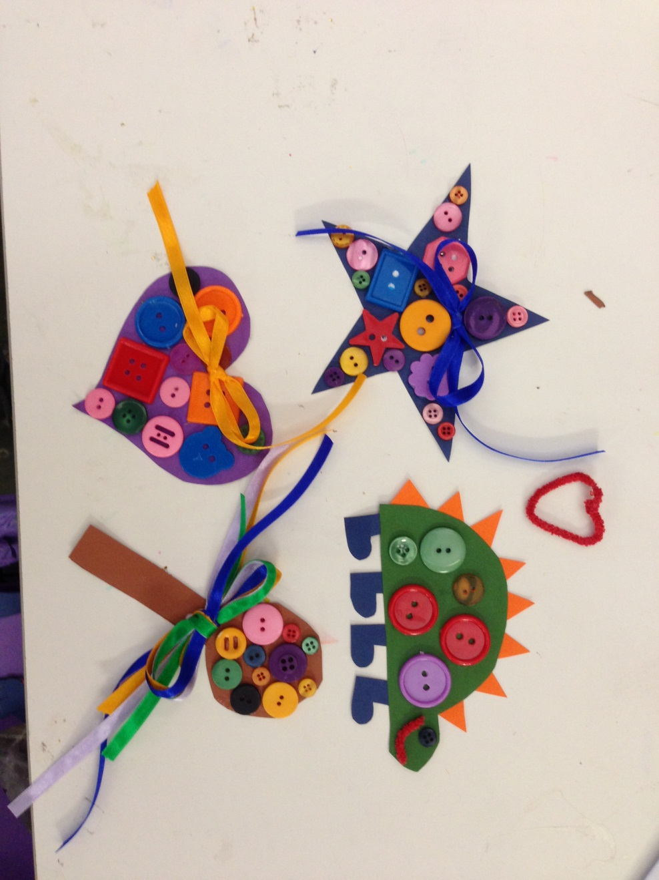

Care of Children

Meals
We have assorted options for Breakfast. This was detailed earlier.
Afternoon Tea is also based on a variety of options. We will do season appropriate foods in the warmer months and more solid winter style foods in the cooler months.
In the warmer months we will provide such foods as:
Dips and crackers and vegie sticks, fruit salad and custard or ice cream, jelly and custard, assorted yoghurt, corn chips and salsa, crisp bread with assorted toppings etc.
In the cooler months we usually provide options such as lasagne, fried rice, nachos, a variety of pastas and other cooked choices for afternoon tea. This is not only to give the children something substantial in their bellies for afternoon tea but it also assists in the colder times of the year if parents cannot get their dinner till later or have to offer a small snack type dinner due to their hectic work day.

Birthdays
Birthdays are celebrated with singing and acknowledging their special day. If your child is celebrating a birthday please let our staff know.

Maintaining Home Language
We encourage and support all families to continue to communicate with their children in their home language. We ask that you share with the teaching team resources that you may have in your home language which might help the staff and children learn more about your culture and home language.

Feedback from Families
Our OOSH welcomes all feedback from families. Your feedback is very important to us. If you have a question, concern, positive affirmation or suggestions for improvement, please make a time to meet with the supervisor. Your feedback will be listened to and the appropriate action taken in line with our complaints policy.

Family Feedback Book
Please use this book to communicate any suggestions or feedback about our service. You may do this anonymously if you choose.

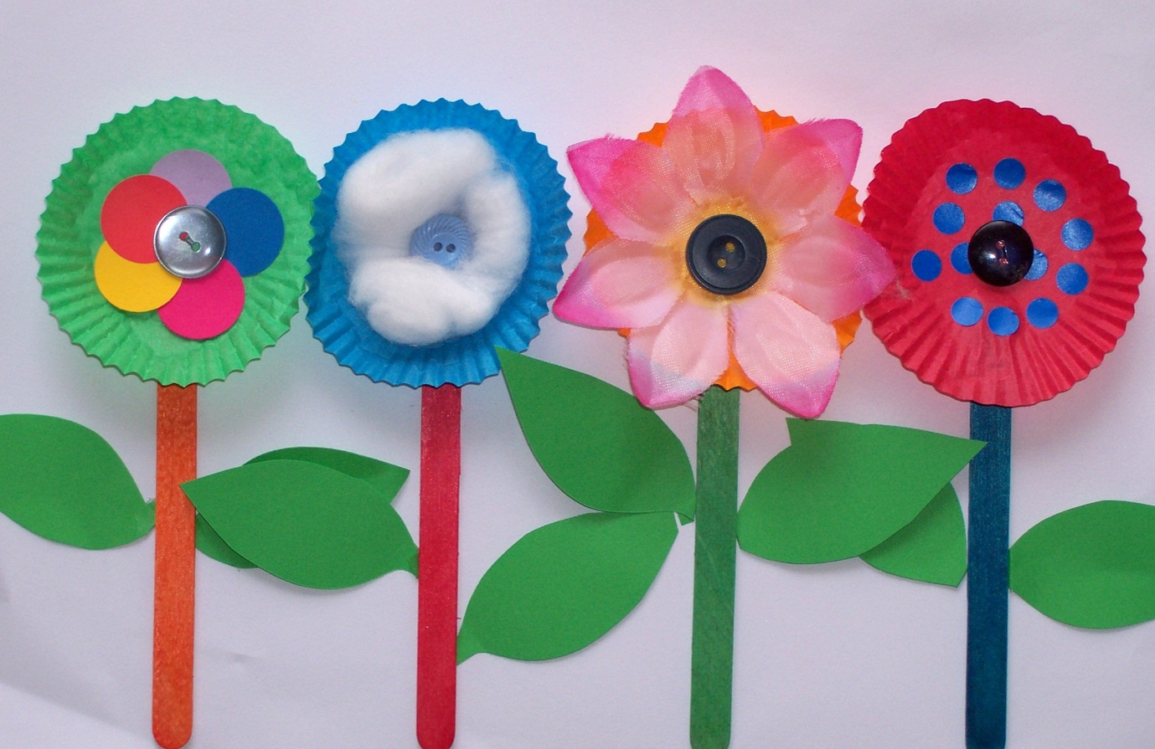

Child Protection

As a community, we all have a role in ensuring our children are safe and able to develop in an environment free from abuse and neglect. If at any time you feel a child is at risk of significant harm please contact the Community Services Help line on 132 111.
All staff that work in children’s services are Mandatory Reporters. This means that if we suspect that a child is at risk of harm, you disclose your child is at risk of significant harm or your child discloses they are at risk of significant harm we will contact Community Services.

Policies and Procedures
Our OOSH has an extensive list of policies and procedures that help to guide our high quality care and practice. They are available for you to read at any time. Ask your educators to be emailed a copy.
Policies are developed and reviewed by us every year. We encourage parent collaboration, so please feel free to give feedback on our policies at any time. Your feedback will also be requested throughout the year by way of the policy feedback sheet.

Health and safety
Hand washing
Parents, educators and children should wash their hands:
- On arrival to and departure from OOSH if need be
- After blowing noses
- Before and after preparing food
- Before and after changing children if help is needed
- After cleaning
- Before and after attending to a sick child or dealing with cuts, abrasions, nose bleeds etc.

Immunisation
Immunisation is a simple, safe and effective way of protecting children from disease. If there is an outbreak of an infectious disease at OOSH, which can be prevented by immunisation, then children who are not immunised are required to stay at home during the outbreak even if they are well. This ensures their well-being and is a direction from the public health unit. Please
be advised that full fees are still applicable for the period of exclusion for Permanent bookings.

Smoke Free Environment
In accordance with the National Regulations our OOSH is a smoke free environment; this includes the car park and footpath.

Evacuations and Emergencies
The service has an evacuation plan which is practised regularly with the children. The attendance register is used as a roll on these occasions so please ensure that you sign in and out at all times. If you happen to be at the service when a drill is being conducted please support the staff by following their directions. Evacuation plans are posted at exit points. Please make yourself familiar with the plan.

Visitors
It is a requirement of the Education and Care Services National Regulation that all visitors (i.e. other than those dropping off or collecting children) must sign in on arrival and wear an identification badge whilst on the School premises.

Sun Safety
We are a Sun Smart OOSH as certified by the Cancer Council. In keeping with our sun protection responsibilities, all children are to wear a hat when outside. This is provided by OOSH if needed, or children simply wear their school hat. We ask that you dress your child in sun appropriate clothing i.e. short or long sleeves (no shoestring straps or singlet tops). Obviously this only applies when they are not in school uniform.
All children, staff and visitors will apply SPF30+ broad spectrum, water-resistant sunscreen before going outdoors and reapply every 2 hours.
The service aims to educate children in effective long term sun safe behaviours. Our playground is very well protected with shade covers and trees that provide lots of shade. Our program and routine is planned so that children are not exposed to the hot sun where possible.

Sick Children and Exclusion Guidelines
The OOSH aims to balance the wellbeing of the individual child with the wellbeing of the group of children. Unfortunately we do not have the time or resources to provide one on one care to children who are unwell. Therefore sick and contagious children must be kept at home.
Parents will be called to collect their child if fever or contagious symptoms are evident. Please make sure you keep your emergency contact details up to date.
We follow the exclusion guidelines from the National Health and Medical Research – ‘Staying Healthy in Childcare’. No child with a fever, vomiting, respiratory infection, diarrhoea, immunisation preventable disease, a transmissible skin infection not yet treated or other suspected infectious illness can attend OOSH. The child must be clear of all symptoms for 24 hours
before returning to OOSH. With infectious diseases such as chicken pox etc a Doctors Certificate may be requested by the centre manager.
It remains the discretion of the supervisor to exclude a child who is unable to participate in the normal routine and activities of the OOSH. Please inform educators if your child has been unwell, been on any medication, previous to their days attendance.
Please inform the OOSH if your child has an infectious illness that has been diagnosed by a Medical Practitioner as the OOSH needs to display a notification for families with a fact sheet to minimise further outbreaks.

Anaphylaxis
An increasing number of children are now experiencing anaphylactic reactions to a variety of items. Anaphylaxis is the most severe form of allergic reaction and can be potentially life threatening. To safeguard the children attending our service we now exclude all foods containing nuts or nut related foods and products.
A notice will be posted at the entry to the service if any other foodstuffs need to be excluded from the environment. For further details see the policy.

Medication Form
If your child has been ill but is well enough to attend and is completing a course of antibiotics, please give the medication to the teaching team and sign the appropriate medication form ensuring the medication has been prescribed by a doctor for your child. The medication must be in the original bottle with the original label and within its expiry date.
Educators will administer the medication at the appropriate time according to the instructions (parent instructions must match instructions on container). Two staff members will check and witness the administering of medication.
For any long term medication, please provide a letter from your Doctor outlining the health condition being treated, the purpose of the medication, instructions for administration and a special action plan if needed (allergy, asthma, and anaphylaxis). We only administer medications in the original bottle or packs distributed by your local pharmacy. It must have the Drs details, name of child, name of medication, dosage, frequency etc. Without these details in that kind of packaging we cannot administer the medication.
Please refer to our policy for further details.

Illness
If your child becomes ill while at the OOSH, we will make every effort to contact you to make arrangements for your child to be collected. Educators will complete an appropriate illness form that details what actions have been taken which you will be asked to sign when you pick up your child.

First Aid
In the event of an accident or injury, the Accident injury form will be completed by educators. Parents are informed of the incident at pick up or if urgent, as soon as possible. Parents are asked to sign the report which is then kept in the child’s file and a copy will be made available to you if you want a copy. In the event of an injury requiring hospital or medical treatment parents are informed and an ambulance is organised. Educators, volunteers and students are informed of and follow our policy regarding and injury procedure. At all times, there are at least two educators on duty with a current first aid qualification.

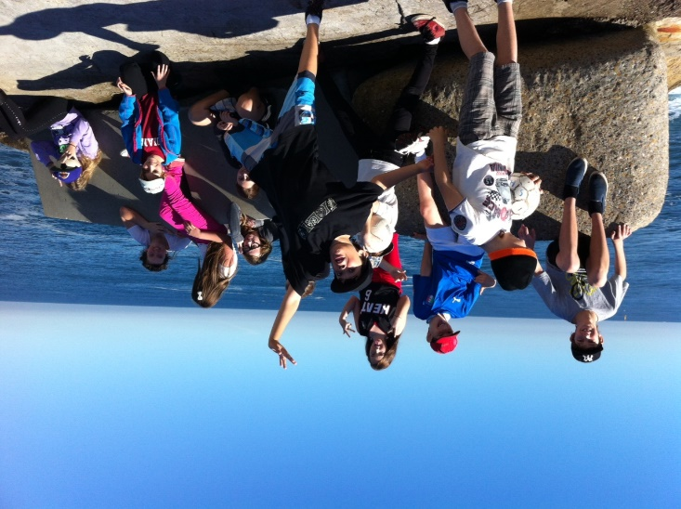

Complaints or Praise?

If you have any problems or issues, or would like to compliment any aspect of Warners Bay OOSH, please contact the following………
-Please speak to the service Educators or Service Manager. They can make a time that is suitable for you to meet and discuss your concern. If you do not get the result you like from this meeting please out your concern in writing to:
Larissa Street -Nominated Supervisor
Merewether Heights OOSH/ Mt Hutton OOSH
c/o 32 James Street
Tingira Heights NSW 2290
Email: Larissa@ooshnewcastle.com.au
Attention to the Nominated Supervisor in the subject line.
Further Communications can be addressed to:
Glenda Dawson
Regional Operations Manager (Hunter/Central Coast)
Department of Education and Communities/Early Childhood
Education and Care Directorate
Telephone: 0249 851 433
Email: ECEC_HCC.region@det.nsw.edu.au
National Body: 1800 619 113
NQAIT: http://www.acecqa.gov.au/regulatory-authorities1
DEC: http://www/dec/nsw.gov.au/what-we-offer/regulation-and-accreditation/early-childhood-education-care

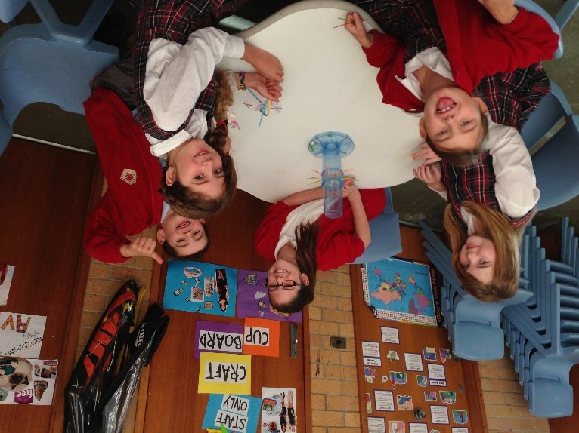
Child Care OOSH Family Agreement

I, ______________________ have read and agree to cooperate and follow all the OOSH policies as available on request from staff. In conjunction to enrolment form we must receive a copy of this parent user agreement.
I hereby declare, to the best of my knowledge, the information provided in my children’s enrolment form is true and accurate.
I will ensure I keep track of my account weekly and endeavour to have this paid weekly as per the agreement with this service.

Parent/Guardian Full Name_______________________
Signature:_____________________________________
Date:_________________________________________
Name of Service________________________________

I, __________________________have read and agreed to the OOSH parent handbook as detailed.
In conjunction to your enrolment we must receive a copy of this parent user agreement.

Parent/Guardian Full Name_______________________
Signature: ____________________________________
Date:________________________________________
Name of Service Enrolled at:_____________________

Thank you for taking the time to familiarise yourself with this handbook.

If you require any further information at any time please see the Supervisor.
All of the team at our OOSH look forward to meeting both you and your children.

